Which sheets are associated with the following 5 protocols as described in U01_Jhou_Aims&ResearchStrategy.pdf?

Runway operant cocaine-seeking (Runway)

Conditioned place preference

Progressive ratio (TS Lever Training, TS Prog Ratio, Progressive ratio)

Punishment resistance (Progressive Punishment)

*Shuttlebox shock escape (Locomotor)

* + * What does this protocol measure? Punishment resistance (pg 7 suggests)? Same as the increasing shock intensity protocol (pg 12)?
* ? Delayed punishment (DP) and two associated DP sheets

And could you include date of experiment on the Excel sheets?

How can we access the plx files?/Could you explain how you transferred information from plx to txt?

For 18 animals, the ID numbers seem to be mistranslated for the plx and txt files (107 txt files).

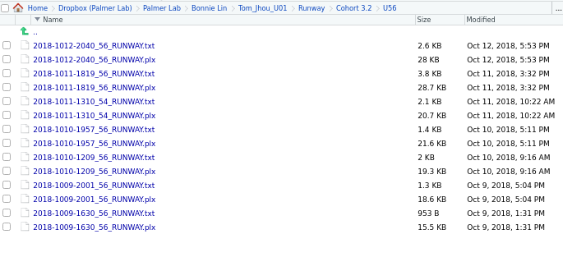

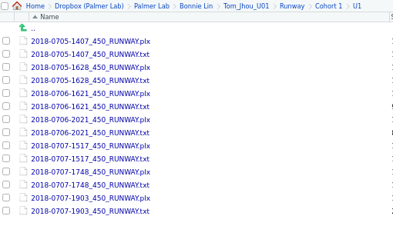

Dropbox:

“_unclassified behavior” = Lever training data for 409 to 424?

“Runway” = Deleting ~8 runs of rat plx and txt files with no replacement (unique IDs include: 406,405,397,396; diff dates)

Questions about Behavioral Data (read only Excel) (by sheets)

1. Runway
   * Note: Gender assignment mismatch (at least for U1-U16)
   * Do the values represent latency in seconds?
   * How should we note/interpret Reversal data? Cocaine aversion?
   * Can you explain the range of the data (Min:0, Max:900)
   * What is the explanation for the trial bins for the averages?
   * What happened to first habituation data? (ex: U61-63)
   * Why do later batches have increased cocaine trials (from Cocaine 7 to Cocaine 12)
   * What trait are you quantifying here?
   * Some values have one digit after decimal and most are whole?
   * What flag/what day should we flag for failed brev cases?
   * Do the color coded (red) cases indicate omit/death cases?
2. Runway males vs females
   * Were different apparatuses used for males vs females?
   * Note:  Because of gender assignment mismatch, the summary stats were miscalculated
   * How are you using the data?
3. Summary pilots
4. TS Average Weights Per Day
5. Schedule (vertical)
6. Schedule(horizontal)
7. TS Lever Training
   * What do the abbreviations mean (FR, ITI, LE)? Retract?
   * What format should the values be in? (“5 out of 15” “23” and “0/1”)
   * What units are these values in? Number of trials?
8. TS Prog Ratio
   * Note: Please ensure that Animal ID is consistent with format of Jhou lab ID

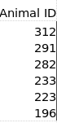From TS Prog Ratio

Vs

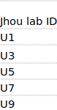Other sheets

* + How is Prog Ratio calculated? # of additional lever presses before timeout/# of lever presses trained

1. Progressive Punishment
   * Missing time and FR? How should we extract these data?
   * Should there be weight %’s in all sessions 1-5
   * What is the difference between block and trial for each shock increment?
   * Could you clarify the protocol in this experiment? Are both the number of levers required to access food and the amount of shock endured increasing?
   * What are you measuring with zigzags?
   * What are the first 2D, second 2D, and last 2D suggesting?
2. PP variance
   * Please explain the row names and interpretation
3. Progressive ratio
   * Difference to TS Prog Ratio (Training Stages?) are post-stabilized response rates (~2-3 days) for leverpressing?
   * Missing body weight %’s
   * Is Max Ratio calculated differently than Prog Ratio?
   * What trait is quantified here?
4. Locomotor
   * Shuttle shockbox data quantifies punishment resistance but unsure about which sheet indicates data values (this sheet is my best guess though it is missing increasing increments of shock (mA))
   * How are the binned counts calculated?
5. Delayed punishment
   * What is the data’s associated protocol?
   * Does the protocol change to mirror the change from binned counts in general to binned counts (2a) and (2b)?